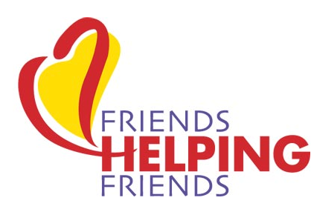

25% Off Coupon for $5
Tuesday, October 16, 2018
In store only 9am – 10pm
Use at any Boscov’s
The AI DuPont High School Marching Band is partnering with Boscov’s Friends Helping Friends program to fundraising for your child’s travel account!
Details:
- You will take as many $5 coupons as you think you can sell.
- Sell them until October 15th.
- Bring the unsold coupons and money for the sold coupons to band practice on Monday night, Oct. 15th.
- For each $5 coupon, your student will get $5 deposited in their travel account.
- Do not give out any coupons that you did not collect money for. All coupons will be tracked. Do not make copies of the coupons.
- Anyone who can sit at the table in Boscov’s Concord Mall the day/night of Oct. 16th to represent AI Band, please contact Missy. Any increments of time appreciated. Coupons sold during your time will go towards your child’s account.

Please contact Missy Weyl with any questions:
(302)530-5450
mweyl@comcast.net

